# HR ANALYTICS DASHBOARD

## DESCRIPTION:
This project analyzes employee attrition, workforce performance, salary distribution, and employee satisfaction using Excel, SQL, and Power BI.

## TOOLS USED :
--Excel
--MYSQL
--Power BI
## DASHBOARD PAGES :
- HR Overview Dashboard
- Attrition analysis Dashboard
- Employees Performance Insights
## KEY INSIGHTS :
- Overtime employees show higher attrition.
- Lower salary bands have increased resignation rates.
- Work-life balance impacts employee satisfaction.
- Delayed promotions contribute to attrition.
## DASHBOARD PREVIEW :
1.HR overview dashboard :
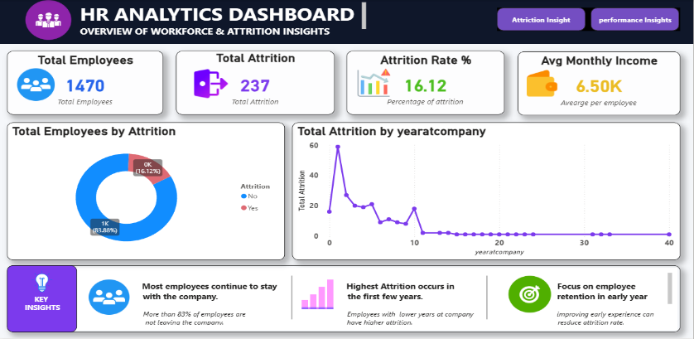
This page provides overall employee and attrition insights.
2.Attrition Analysis Dashboard:
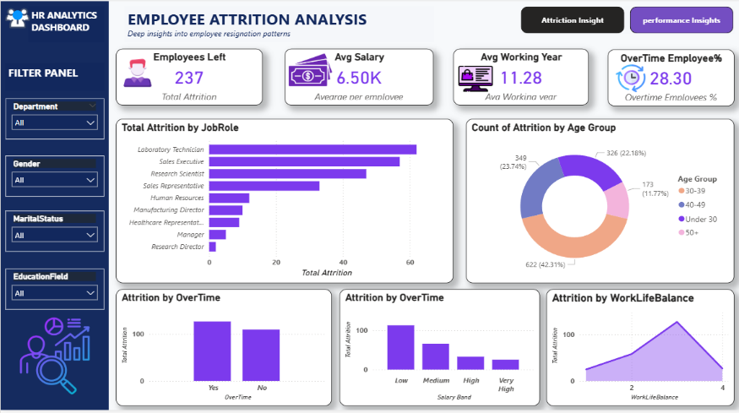
This page provides insights into employee performance, job satisfaction, work-life balance, salary distribution, and promotion analysis to evaluate workforce productivity and employee experience.
3.Employee Performance Insights Dashboard :
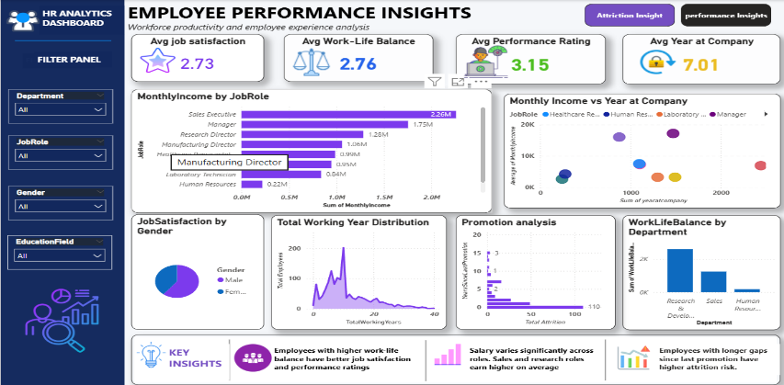
This page provides insights into employee performance, job satisfaction, work-life balance, salary distribution, and promotion analysis to evaluate workforce productivity and employee experience.
##PROJECT OUTCOME :
This dashboard helps HR teams identify the major factors affecting employee attrition and workforce performance, enabling data-driven decision making.

--------------------------- THE END-------------------------------------

